**- short title/desc for artwork**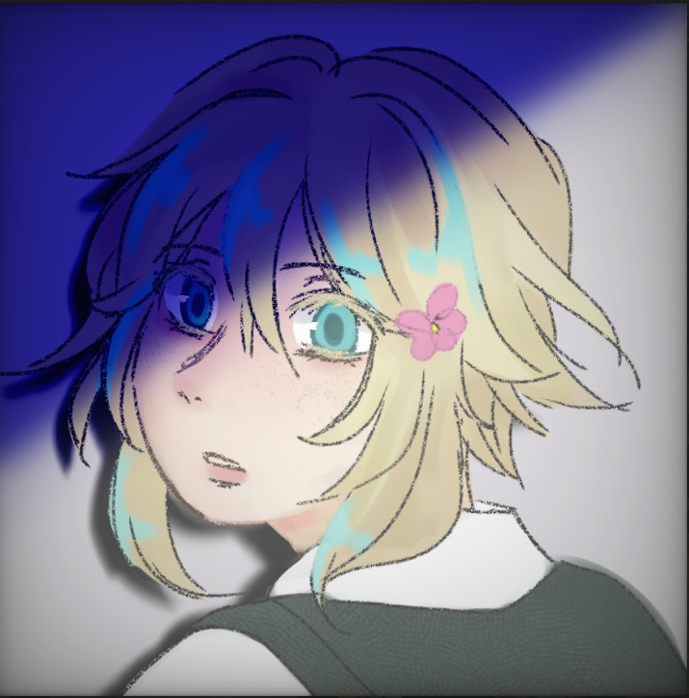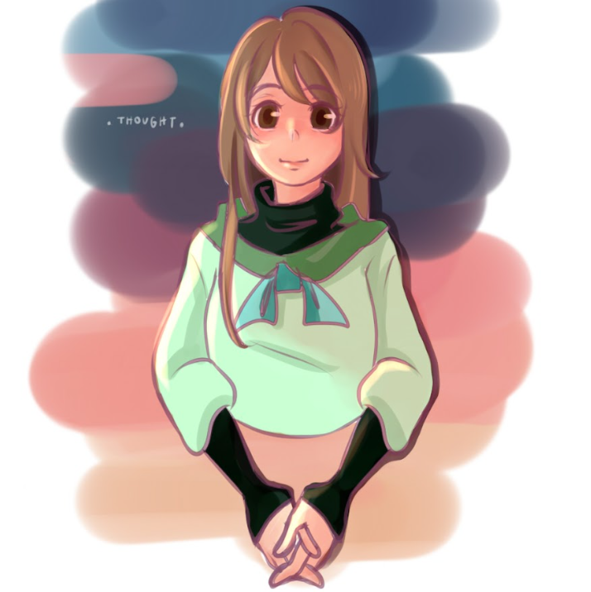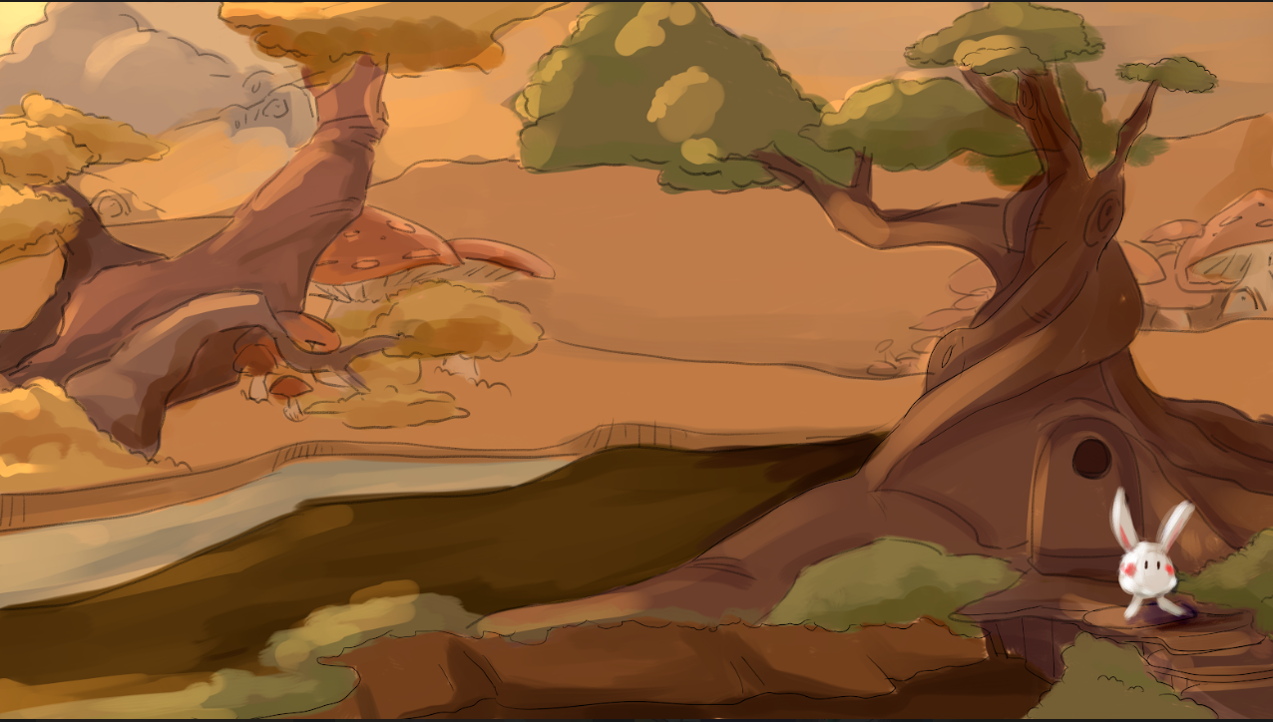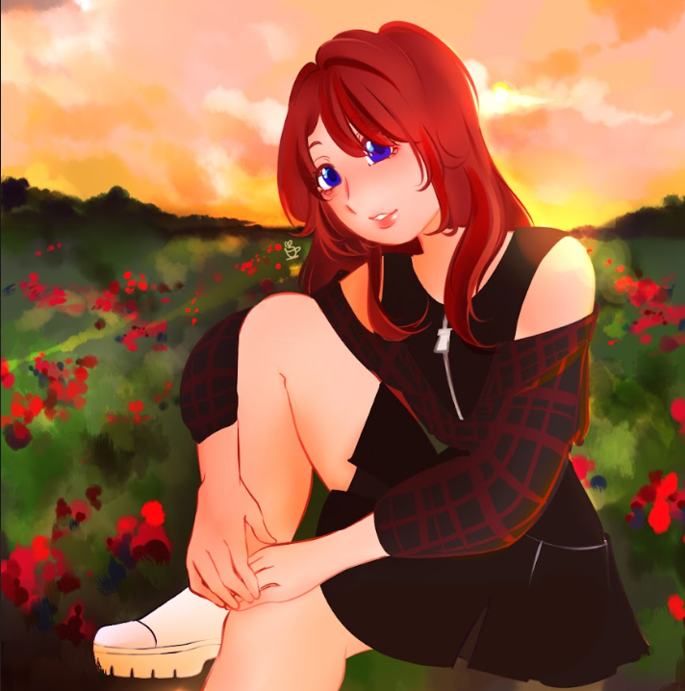

**Dustbunny**

**1.** Dustbunny is on their way to pick some berries ♡.

**SHOT**

**2.** Photocard of Basil, Omori. The one and only Bagel ⸜(*ˊᗜˋ*)⸝

**THOUGHT**

**3.** Angst piece. Feeling numb, but your head is full of thoughts.

**SUNSET**

**4.** Sunkissed ⋆｡‧˚ʚ☀️ɞ˚‧｡⋆

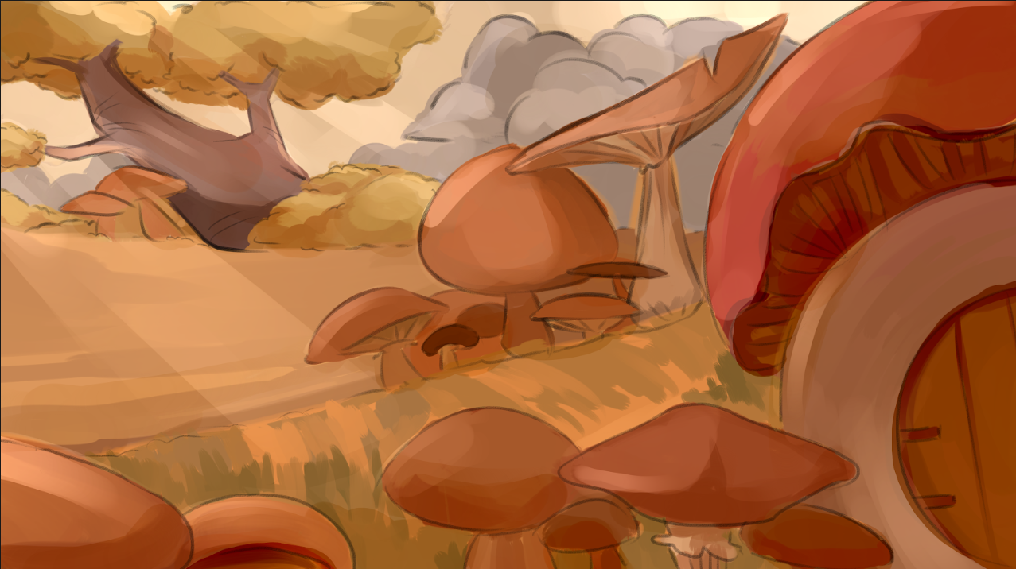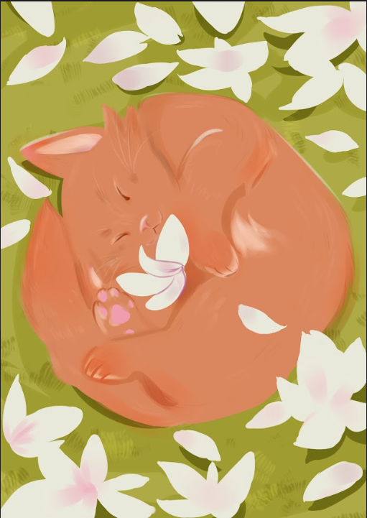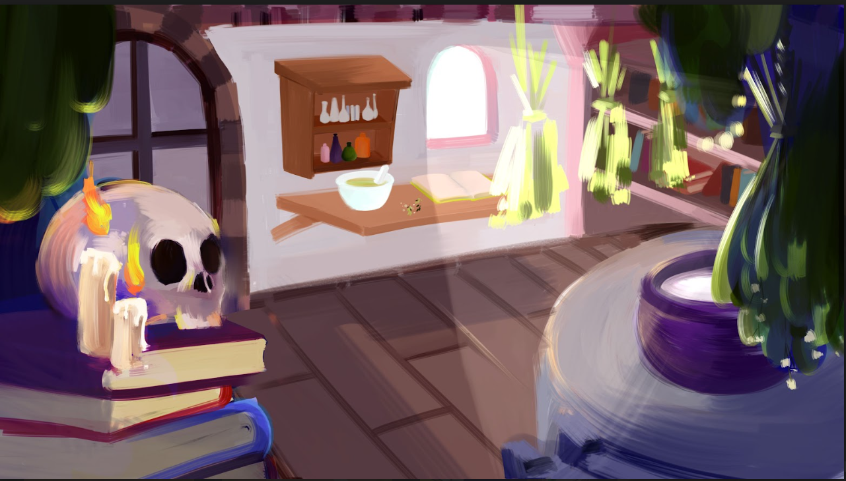

**MUSHROOM**

**5.** Mushroom mushroom mushroom

You make me feel a little funny inside.

**RAINING PETALS**

**6.** Kitty sleeping surrounded by magnolia petals ꕤ.

|  |
| --- |

**UNTITLE (EXTRA)**

**7.** Witchy witchy stuff.

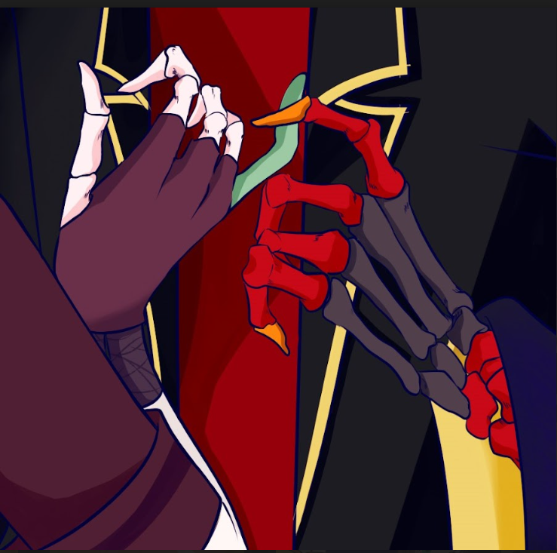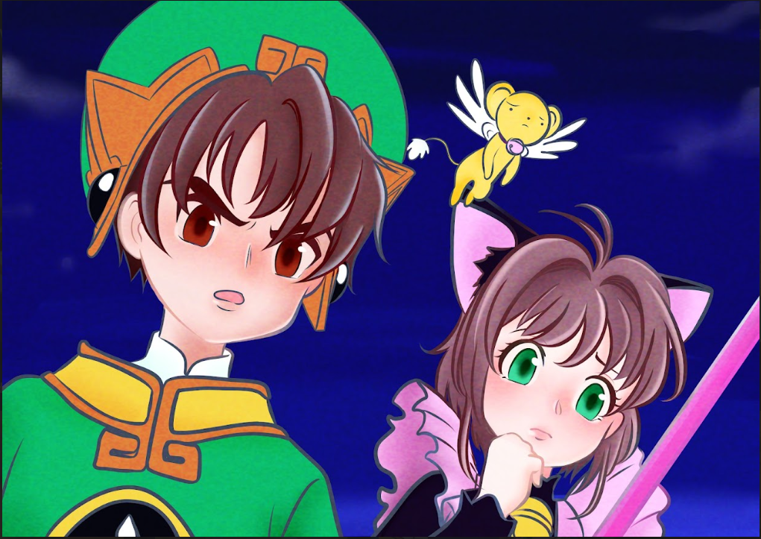

**THUNDER (EXTRA)**

**7.** CCS S1 Eps8. Redraw of Sakura and Syaoran first battle together for CLOW CARD .+:｡(ﾉ･ω･)ﾉﾞ

**PHALANGES (EXTRA)**

**7.** Skelly time ✧

**- 1 favorite quote**

### Sky Nature Milk BREAD _(:3 」∠)_♡

**- short bio (50-150 words max)**

Look at the sky; the first cloud you see could be your fluffy companion throughout the day.

**- socmed handle or email**

Cara: @olivelatte

Email: mizahlina610@gmail.com